NED University of Engineering & Technology Department of CIS Engineering



Batch: 2023

NM ASSIGNMENT

NAME: Fatima Shahid

ROLL NO: CS-23007

COURSE: Numerical Method (MT-442)

SUBMITTED TO: Hussain Kausar

Apply Numerical Methods using Python

(Graphical Analysis)

QUESTION
You are required to apply numerical methods using Python programming to solve the following problems and present the results graphically:
(a) Apply Numerical Integration Techniques:
Apply the following methods:
- Trapezoidal Rule
- Simpson’s 1/3 Rule
- Simpson’s 3/8 Rule
To evaluate the integrals:
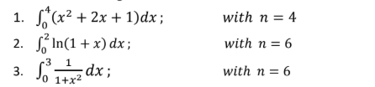
Apply plotting techniques to visualize each function and shade the area under the curve.
(b) Apply Numerical Methods for Differential Equations:
Apply:
- Modified Euler Method
- Runge-Kutta 4th Order (RK4) Method
to solve:
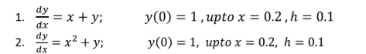
Apply graphical comparison to plot:
Requirements:
1. Write complete Python code for all methods.
2. Plot graphs for:
o Integration (area under curve)
o Differential equations (numerical vs exact solution)
3. Display numerical results clearly in the output.
4. Provide a result statement explaining your findings and comparison of methods.
5. Use proper coding practices (functions, comments, structure).
6. Compile your work into a well-formatted PDF report that includes:
o Python code
o Graphs
o Results and explanation

ANSWER

PART (a
CODE
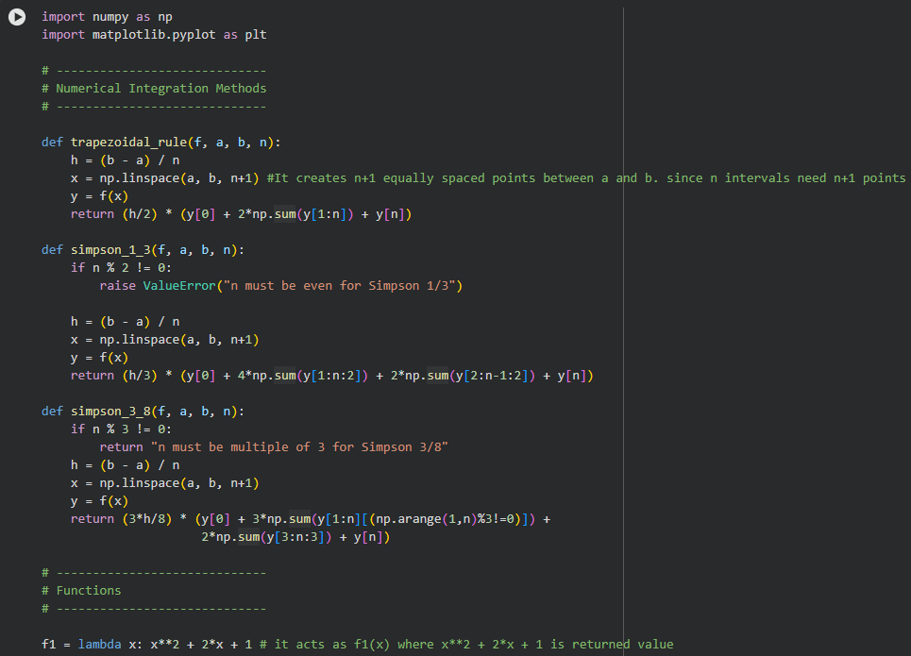
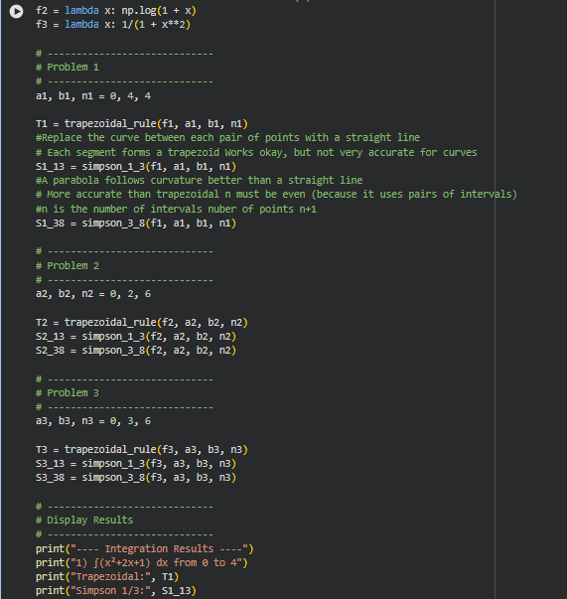
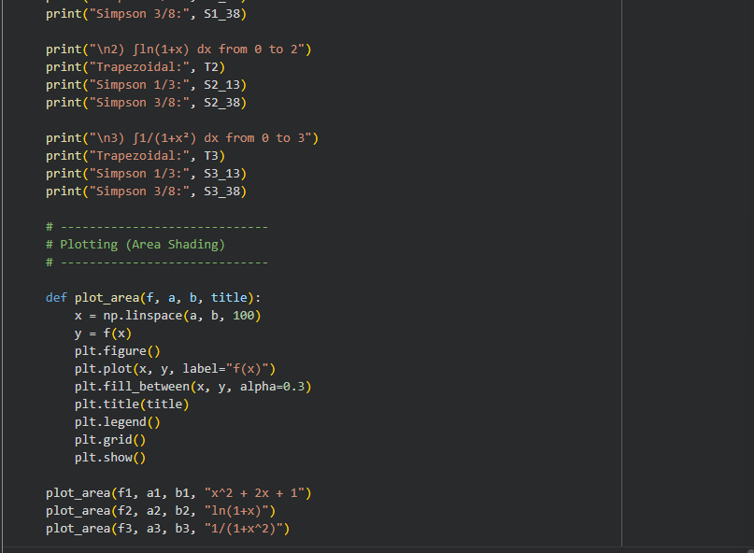

RESULTS & VISUALIZATION
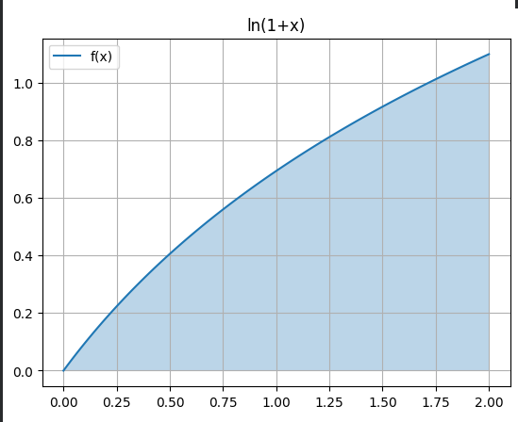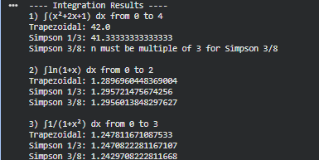

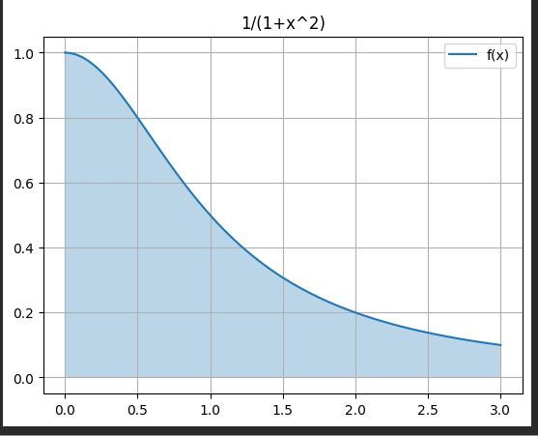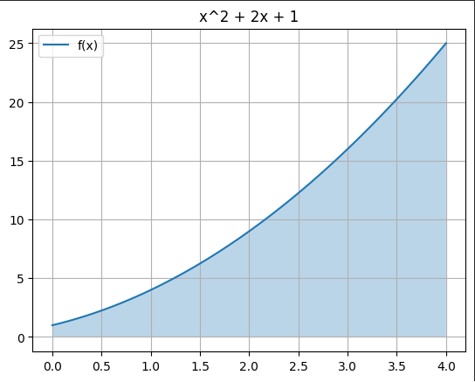

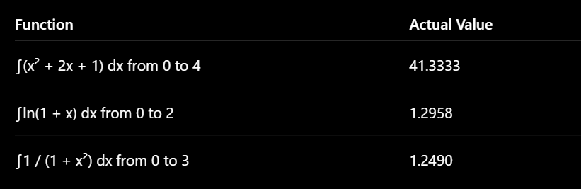

CONCLUSION FOR PART(a)
Numerical Integration:
Simpson’s 1/3 Rule produced the most accurate results in all cases. Trapezoidal Rule showed larger error due to linear approximation. Simpson’s 3/8 Rule also gave good accuracy but depends on n being multiple of 3.

PART(B)
CODE
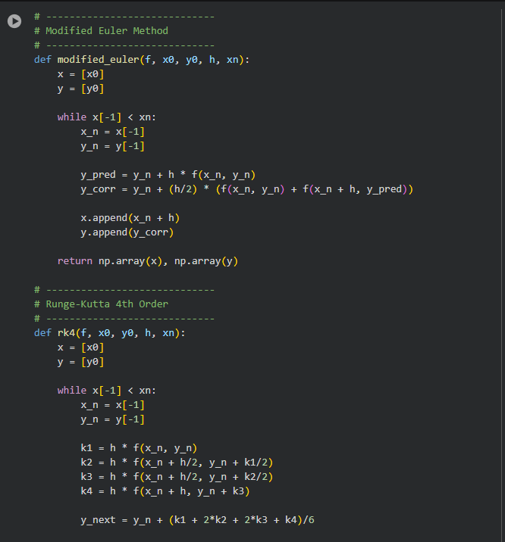
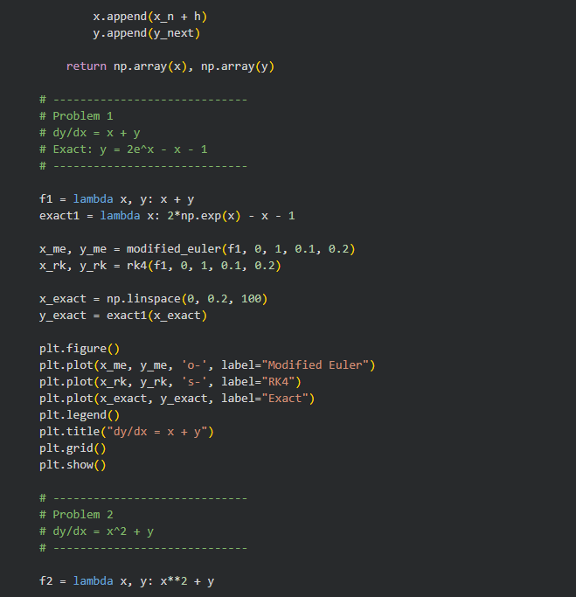

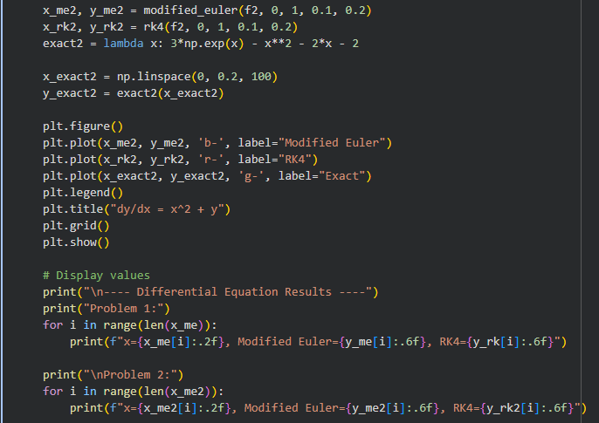

RESULTS & VISUALIZATION
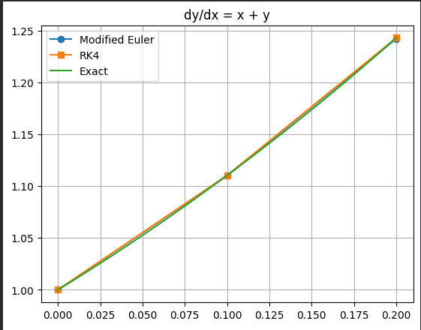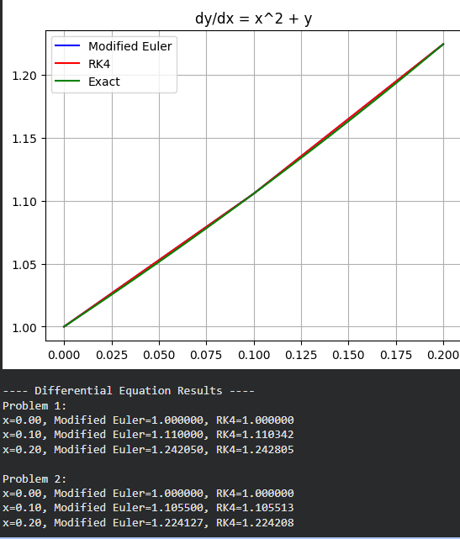
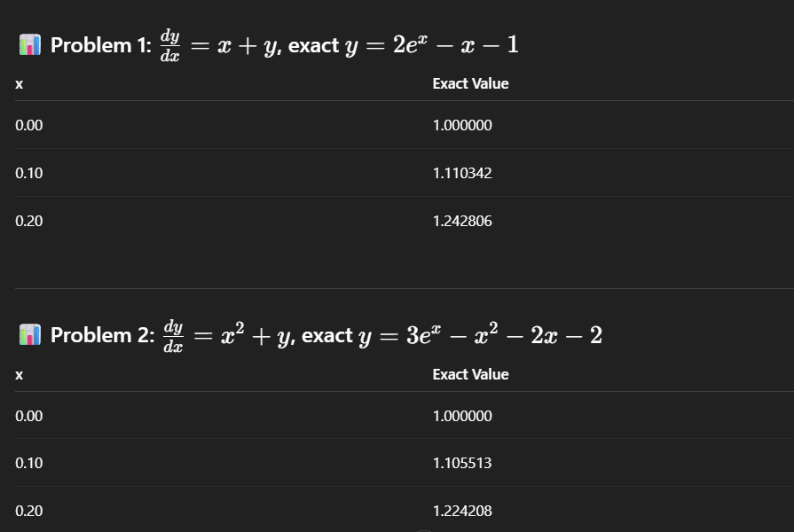

CONCLUSION FOR PART(B)
Differential Equations:
RK4 method is significantly more accurate than Modified Euler. Modified Euler improves over simple Euler but still has noticeable deviation. Graphs clearly show RK4 almost overlapping with exact solution.

